**Assembly instruction for CPAP device**

**System Diagram**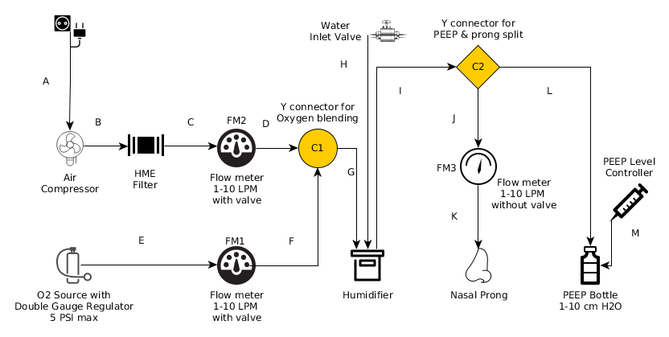

Step 1.1 Prepare the cut outs in the main enclosure

|  |  |  |
| --- | --- | --- |
| **Step** | **Instruction** | **Image** |
| 1.0 | Make a 40mm X 50mm clearance for cable inlet at any of the side walls of the enclosure. | Fig.0 |
|  | Note the type of the flowmeter. make two pairs of 15mm holes 70mm apart for fitting in the flowmeter. | Fig.1 |
| 1.2 | Place it as shown | Fig.2 |
| 1.3 | Fix the screws to keep the final output flowmeter in place. | Fig.3 |
| 1.4 | Cut two PVC tubes for each flowmeter & connect the elbow connectors to the tubes as shown in the picture. | Fig.4 |
| 1.5 | Connect the tubes to the flowmeter. The outputs of both air & oxygen carrying flowmeters are connected through a Y connector.  Please refer to the system schematics at the end of the document for more details | Fig.5 |
| 1.6 | Drill two holes of 5mm dia & 65mm apart and fix the bottle holder in that location. | Fig.6 |
| 1.7 | Prepare the PEEP bottle assembly | Fig.7 |
|  | PEEP bottle to be mounted as shown. | Fig.8 |
|  | Prepare the base-plate for compressor mounting.  Placement of the holes may differ depending on their actual mounting arrangement | Fig.9 |
| 1.8 | Assemble the pump & place it in the mounting holes.  Make 4 mounting holes for placing the baseplate inside the enclosure. Dimension: 190mm X 90mm | Fig.10 |
|  | Connect the compressor outlet to the flowmeter inlet as shown.  The outlet of the flowmeter to be connected to the inlet of the humidifier. | Fig.11 |
| 1.9 | Preparation of the Humidifier  Drill three holes of 12mm dia & 50mm apart and place the threaded elbow connector as shown in the image.  Inlet and outlet port of the humidifier & water filling connector.  Some masking tape/ glue gun can be applied for achieving better grip & air-tightness. | Fig.12    Fig.13 |
| 1.10 | A ball valve is set at the top of the system to fill water in the humidifier.  Place the humidifier chamber in the appropriate place. | Fig.14 |
| 1.11 | The final placement of compressor & humidifier | Fig.15 |
| 1.12 | Drill a hole of 12mm diameter at the center of the cap of the bottle & place the threaded connector & 180mm PVC pipe of 12mm internal diameter.  Drill 4 holes of 5mm diameter at the cap of the bottle to insert luer lock tubing. This tube will be connected to a 60ml or 100ml syringe for adding or reducing water to the PEEP bottle. | Fig.16 |
| 1.13 | Cut a 115mm tube & place it in between the humidifier chamber outlet & Y connector.  Connect the nasal cannula & tubing to the wye connector. | Fig.17 |
| 1.14 | Assembled bubble CPAP | Fig.18 |